

National Textile University
Department of Computer Science
Subject
Mobile Application Development

Submitted to:
Sir Rehan Servar

Submitted by:
Abdul Rehman Sudais

Registration Number
23-NTU-CS-1123

Lab
Evaluation

Semester
6th

CODE:
import 'package:flutter/material.dart';

void main() {
runApp(MyApp());
}

class MyApp extends StatefulWidget {
@override
State<MyApp> createState() => _MyAppState();
}

class _MyAppState extends State<MyApp> {
bool _isDark = false;

void _toggleTheme() {
setState(() {
_isDark = !_isDark;
});
}
@override
Widget build(BuildContext context) {
return MaterialApp(
debugShowCheckedModeBanner: false,
themeMode: _isDark ? ThemeMode.dark : ThemeMode.light,

theme: ThemeData(
brightness: Brightness.light,
primarySwatch: Colors.blue,
),

darkTheme: ThemeData(
brightness: Brightness.dark,
),

home: ScheduleScreen(
isDark: _isDark,
onToggleTheme: _toggleTheme,
),
);
}
}

class ScheduleScreen extends StatelessWidget {
final bool isDark;
final VoidCallback onToggleTheme;

ScheduleScreen({
required this.isDark,
required this.onToggleTheme,
});

final List<Map<String, String>> classes = [
{
"card": "Card1",
"time": "8:00 - 9:30 AM",
"subject": "Flutter Developer",
"room": "Room 201",
},
{
"card": "Card2",
"time": "9:30 - 11:00 AM",
"subject": "Data Structure",
"room": "Room 105",
},
{
"card": "Card3",
"time": "11:00 - 1:30 PM",
"subject": "Database System",
"room": "Lab 02",
},

];

@override
Widget build(BuildContext context) {
return Scaffold(
appBar: AppBar(
title: Text("My Schedule",
style: TextStyle(
fontSize: 25,
fontWeight: FontWeight.bold,
),),
actions: [
IconButton(
icon: Icon(
isDark ? Icons.light_mode : Icons.dark_mode,
),
onPressed: onToggleTheme,
),
],
),

body: Padding(
padding: const EdgeInsets.all(16.0),
child: SingleChildScrollView(
child: Column(
children: [
// Cards
for (var item in classes) ...[
Card(
elevation: 5,
child: Padding(
padding: const EdgeInsets.all(16.0),
child: Column(
crossAxisAlignment:
CrossAxisAlignment.start,
children: [
Text(
item["card"]!,
style: TextStyle(
fontSize: 16,
fontWeight: FontWeight.bold,
color: Colors.purple,
),
),
SizedBox(height: 12),
Text(
item["time"]!,
style: TextStyle(
fontSize: 16,
fontWeight: FontWeight.bold,
),
),
SizedBox(height: 8),
Text(
item["subject"]!,
style: TextStyle(fontSize: 16),
),
SizedBox(height: 8),
Text(
item["room"]!,
style: TextStyle(fontSize: 15),
),
],
),
),
),

SizedBox(height: 15),
],
],
),
),
),
);
}
}

OUTPUT:

- LIGHT THEME:
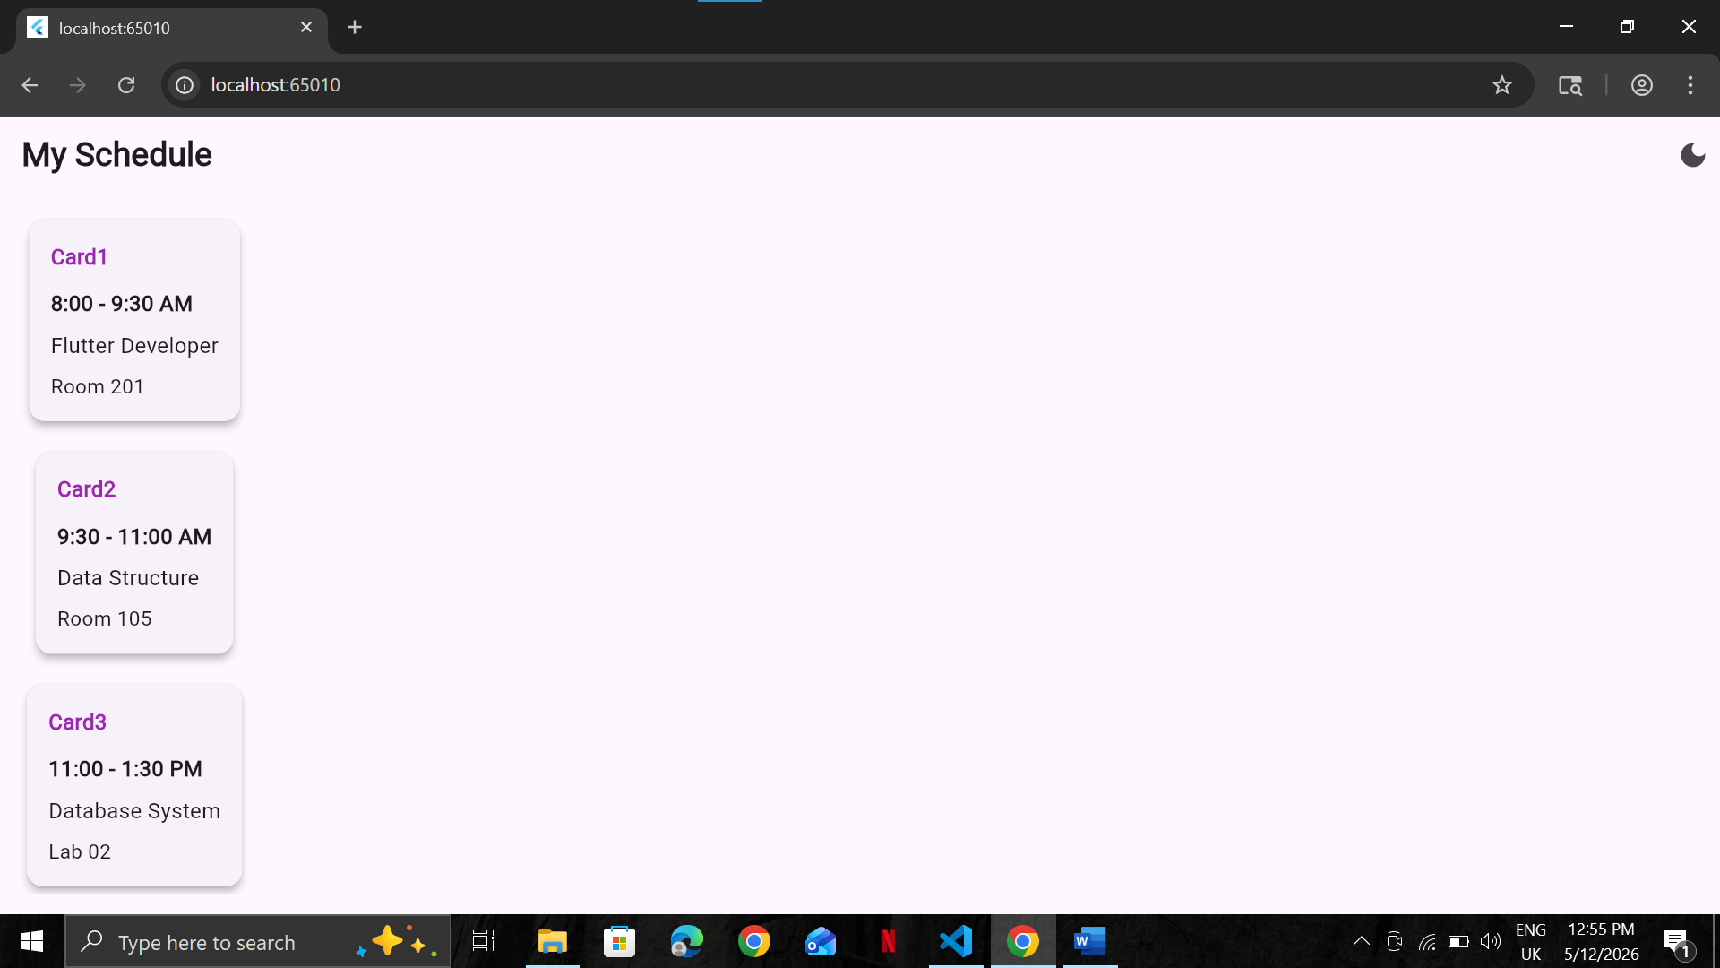

- DARK THEME:
